RC-Charter2 Date Range Error Trap

Applications interface designers must always keep in mind that bad input produces bad output. Therefore, it’s important to make sure that the applications include extensive error trapping. For example, if the end user wants to generate a set of aircraft CHARTER records for some specified date range, the input requirements include a starting data and an ending date. At the very least, the application must check to see if, in fact, the date entries were made. In addition, if the two dates yield no records, that fact must be made clear. (It’s better to let the end user know that there are no matching records than to generate a blank form and the let the end user figure out what went wrong. (Worse, if the output is a report, that report will list an error for each of the output variables.)

To trap date input errors and/or omissions, evaluate the following scenarios and actions:
- The end user fails to enter a starting date. Action: Create a message box to alert the user. A message such as “Please enter a starting date.” will do the job.
- The end user fails to enter an ending date. Action: Create a message box to alert the user. A message such as “Please enter an ending date.” will do the job.
- The end user enters dates for which there are no data. Action: Create a message box that tells the end user that “There are no charter records between ##/##/# and ##/##/##.” will be sufficient.

Because we’ll use a query in which the criteria are based on SQL’s BETWEEN function, there is no need to specify that a starting date must be at least equal to the ending date. The BETWEEN function’s output will be the same, whether the starting and ending dates are, respectively, 8/15/99 and 8/20/99 or 8/20/99 and 8/15/99. (However, if your query criteria specify that >= txtStartingDate and <= txtEndingDate, you’ll have to add an error trap that checks to see if the ending date is at least equal to the starting date.)

To see the error traps in action, let’s use the date range input form shown in Figure 1. The form is shown in design format to illustrate the use of unbound textboxes to receive the input. You’ll discover later that the (hidden) flag textbox will be used to temporarily store a primary key value for the record found in the CHARTER table.

Figure 1 The frmCharterSearchDateRange Form
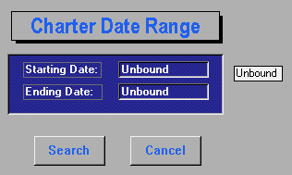

Hidden textbox named Flag

Textbox name: txtStartingDate

Textbox name: txtEndingDate

On click: mcrCharter.CancelCharterDateSearch
On click: mcrCharter.CharterSearchBy DateRange
If no data entry is made in Figure 1’s txtStartingDate textbox and you select the Search command button – or you simply press the Enter key --, the message box shown in Figure 2 will be generated. Failing to make a data entry in the txtEndingDate textbox will generate the message box shown in Figure 3.

Figure 2 Starting Date Reminder
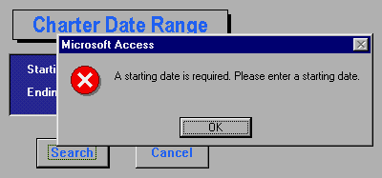

Figure 3 Ending Date Reminder
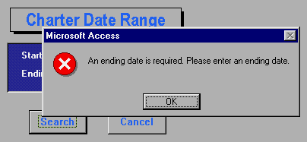

If you enter a set of dates for which there is no corresponding record in the CHARTER table, the system must generate a message box in which the user learns why no output will be generated. For example, if you enter the starting date 8/15/00 and the ending date 8/20/00 as shown in Figure 4, you’ll see the message box in Figure 5. Note that the message box includes the actual entries made to provide proper feedback.

Figure 4 Date Range Entry
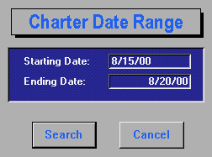
Figure 5 No Data Message Box
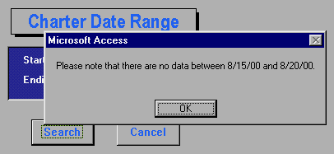

When you press the OK button shown in Figure 5, the system will place the cursor back on the starting date entry. You can then enter the values shown in Figure 6 to produce the output shown in Figure 7.
Figure 6 Valid Date Range
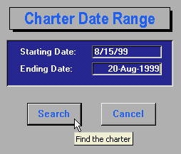

Figure 7 The Charter Records for the Specified Date Range
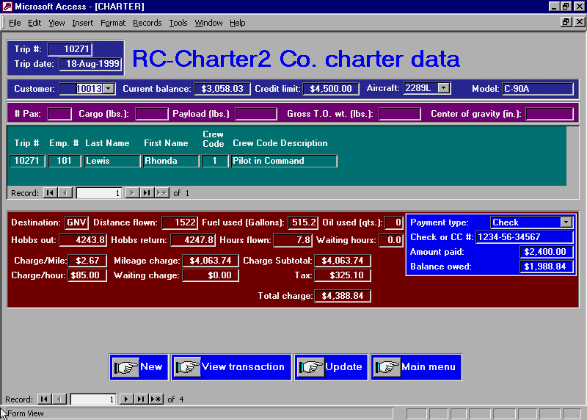

The two macros referenced in Figure 1’s mcrCharter macro group,

mcrCharter.CancelCharterDateSearch

and

mcrCharter.CharterSearchBy DateRange

contain the macros, actions, and action arguments shown in Table 1.

Table 1 Error Trap Macros, Their Actions, and Their Action Arguments

Macro Name Condition Action Action Argument

MaxSize
MaxSize

CharterSearchByDateRange
Echo Echo on: No
Hourglass Hourglass on: Yes

[Forms]![frmCharterSearchByDateRange]![txtStartingDate] Is Null
… MsgBox A starting date is required. Please enter a starting date.
Beep: No
Type: Critical
… GoToControl txtStartingDate
… StopMacro

[Forms]![frmCharterSearchByDateRange]![txtEndingDate] Is Null
… MsgBox An ending date is required. Please enter an ending date.
Beep: No
Type: Critical
… GoToControl Control name: txtEndingDate
… StopMacro

SetValue Item: [Forms]![frmCharterSearchByDateRange]![Flag]
Expression: DLookUp("[CHAR_TRIP]","[qryCharterByDate]")

[Forms]![frmCharterSearchByDateRange]![Flag] Is Null
… RunCode MsgBox("Please note that there are no data between " &
[Forms]![frmCharterSearchByDateRange]![txtStartingDate] &
" and " &
[Forms]![frmCharterSearchByDateRange]![txtEndingDate] & ".")
… GoToControl Control name: txtStartingDate
… Stopmacro

OpenForm Form Name: frmCharterByDate
View: Form
Date Mode: Edit
Window Mode: Normal
Maximize
Close Object Type: Form
Object Name: frmCharterSearchByDateRange
Save: Prompt

Table 1 (Continued) Error Trap Macros, Their Actions, and Their Action Arguments

Macro Name Condition Action Action Argument

CancelCharterDateSearch
Echo Echo on: No
Hourglass Hourglass on: Yes
Close Object Type: Form
Object Name: frmCharterSearchByDateRange
Save: Prompt

